# CS 590 Machine Learning

# Homework 05

# (Ashwini Kulkarni)

**Qus. 1 Ans. ->**

**Given Data:**

* Value Scale: 0 to 1 for features.
* F features
* Instance consider for each office
* Delimiter is “ “
* Target is price.
* Test data will be instance with missing price value. Sample Output will be expected result.
* Instance having price value will be treated as training data
* Instance with missing price will be test data.

**Code Files:**

* hw5.py
* input files: Data.txt , Test.txt

**Qus.2 Ans. ->**

**SVMs with a polynomial kernel:**

Yes we can use SVMs, with a polynomial kernel. Because

* Using Kernel we can transformation of variables from nonlinear to linear space.
* As it can be used as classification technique for linear and nonlinear Space. In given hacker rank example we can use polynomial kernel.
* In SVM it leaves maximum margin on both side (road width on following image), therefore it is less prone to miss classification errors. Also it is less likely to result into over fitting.

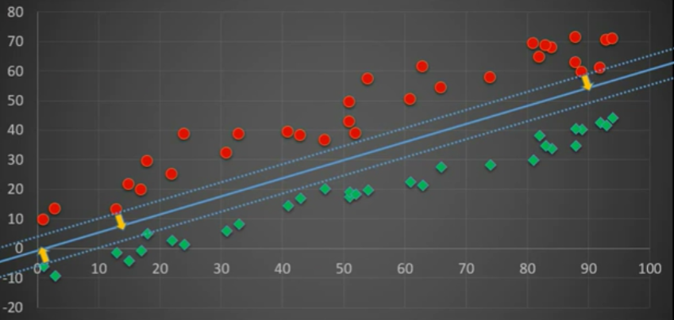

* Complexity with variables (k dimensions - features) is linear. Given example have 2 features, so we can easily apply SVMs, with a polynomial kernel technique.
* It can work with smaller dataset. (Given dataset for example is small)